

Mathematics Specialist Unit 2 - 2021

Test 6

Complex Numbers and Matrices

Name: ______________________ Total Marks:__________

Task type: Response

Time allowed for this task: 60 minutes, in-class, under test conditions
Section One: Calculator-free 28 minutes ( 26 marks)
(2 Minutes Reading – 26 Minutes Working)
Section Two: Calculator-assumed 32 minutes ( 29 marks)
(3 minutes Reading - 29 minutes working)

Materials required: Calculator with CAS capability (to be provided by the student)

Standard items: Pens (blue/black preferred), pencils (including coloured), sharpener, correction fluid/tape, eraser, ruler, highlighters

Special items: Drawing instruments, templates, notes on one unfolded sheet of
A4 paper, and up to three calculators approved for use in the WACE examinations
Formula sheet

Marks available: 55 marks

Task weighting: 7%

Section One : Calculator Free 26 Marks
Time Allowed 30 minutes

Question 1 (8 marks)

Let $z=2+5i$ and $w=8-3i$. Find

- $w-z$

- $2z-iw$

- $Im(w)+Re(z)$

- $\overline{z+w}$

- $zw$

- $\frac{w}{z}$

Question 2
[4 marks]
If ${(a-4i)}^{2}=9+bi$. Find $a$ and $b$.

Question 3
[3 marks]

Determine all complex solutions to the equation $z^{2}+2z+10=0$.

Question 4
[3 marks]
Determine the equation of the real quadratic $f(z)$ in the form $z^{2}+bz+c$ given that $f\left(4-3i\right)=0$.

Question 5
[3 marks]

Express the real quadratic polynomial $z^{2}-4z+16$ as a product of its linear factors.

Question 6
[3 marks]
If $z=a+bi$ and $w=c+di$ , where $a, b, c ,d ∈R$ real Prove that$\overline{z+w}=\overline{z}+\overline{w}$.

Question 7
[2 marks]

A triangle on the Cartesian plane is transformed by the matrix and then by the matrix .
Find the single matrix that will transform the triangle to the final image.

Section Two : Calculator Assumed 22 Marks
Time Allowed 30 minutes Name:_______________________

Question 8
[6 marks]
The location of$u,v$ and $w$ in the complex plane are shown below. Plot and label the following

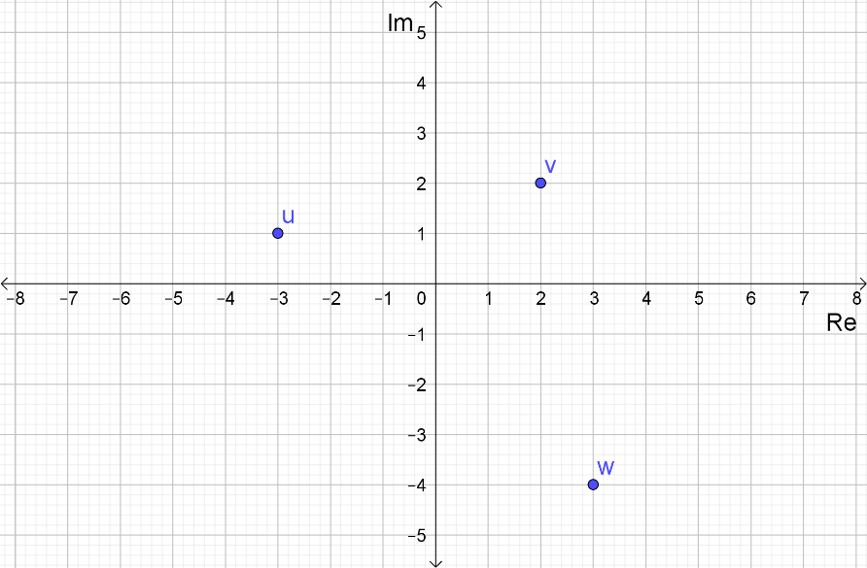
- $z_{1}=2u$

- $z_{2}=w-2\overline{v}$

- $z_{3}=iu$

- $z_{4}=3-wi+v$

Question 9
[4 marks]
- What is the matrix for the transformation T: (x, y) (2x – 3y, 5x + y)?

- Find the image of the triangle A(3, –2) B(5, 3) C(1, 6) under the transformation T.

Question 10
[7 marks]

The vertices of a rectangle are $A(-2,-1)$, $B(5, -1)$, $C(-2, 3 )$ and $D(5,3).$

Transformation $P$ is a translation by vector $\left[\begin{matrix}-2 \\ 5\end{matrix}\right]$.

- State the coordinates of the image of $A$ after the rectangle is transformed by $P$.
(1 mark)

The transformation matrix Q is $\left[\begin{matrix}0 \\ 5\end{matrix} \begin{matrix}4 \\ 0\end{matrix}\right]$.

- State the coordinates of the image of $B$ after the rectangle is transformed by $P$ then $Q$.
(2 marks)

- Find the area of the rectangle after it has been transformed by$P$ then $Q$.
(4 marks)

Question 11
[3 marks]

Use matrices to find the image of the line $x-3y=1$ after it is reflected in the line$y=-x$.

Question 12
[5 marks]

The triangle with vertices $O(0, 0), A(2, 0)$ and $B(0, 3)$ is mapped to the triangle $O’A’B’$ by the transformation represented by the matrix $\left[\begin{matrix}4 & x \\ x & y\end{matrix}\right]$. The area of triangle $O’A’B’$ is 36 cm² and $A’$ has coordinates $(8, 0).$ Find the value of $x$ and $y$.

Question 13
[4 marks]

A point A is transformed by matrix M to A’ and then by matrix N to A’’, where M is the transformation that rotates 30$°$ anti-clockwise about the origin and N is the transformation that dilates by a scale factor of 4 in the y direction.
Find the single matrix that will transform A’’ back to A.

